

Technical Documentation

Svm Dr - Re-initialize existing Svm Dr

nov 2018

*Number of pages : 3*

*Version : 1.0.1*

# Document Information

## Revision History

|  |  |  |  |  |
| --- | --- | --- | --- | --- |
| Date | Version | Status | Prepared by | Comments |
| 2017-09-01 | 1.0.1 | Draft | WFA | Initial Draft |
|  |  |  |  |  |
|  |  |  |  |  |
|  |  |  |  |  |

## Document Control

|  |  |  |  |
| --- | --- | --- | --- |
| Role | Name | E-mail | Telephone |
|  |  |  |  |
|  |  |  |  |
|  |  |  |  |

## Approval

|  |  |  |  |
| --- | --- | --- | --- |
| Role | Name | Signature | Sign-off Date |
|  |  |  |  |
|  |  |  |  |
|  |  |  |  |
|  |  |  |  |

## Table of Contents

Document Information 2

Revision History 2

Document Control 2

Approval 2

Table of Contents 3

# Introduction

## Purpose

This document defines the operation of the workflow, input parameters and performed tasks.

## Description

Is the same workflow as "create new svm dr", but in this case we assume the relation is already created.

Run this workflow if the initial create workflow had some issues (warning or errors, such as : unable to join in AD).

It's safe to run this workflow, it's basically an update workflow with some additional check builtin.

## Assumptions

For individuals reading this document please note that the following has been assumed:

* A familiarity with NetApp products and technologies
* WFA configuration and NAS system configuration meets requisites and configuration defined in the documents "Storage Engineering WFA Standards" and "Storage Engineering WFA NAS Provisioning and amendments Standards"

# Workflow Inputs and outputs

## Screenshot

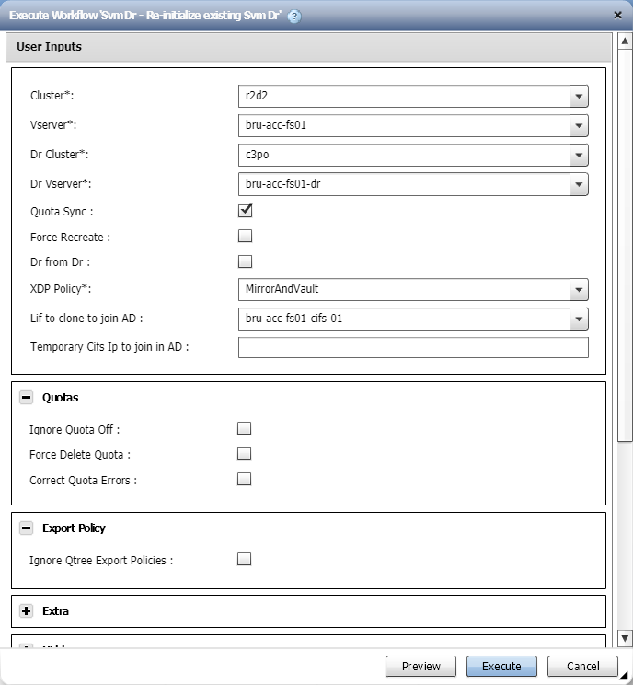

## Workflow inputs

The table below shows the general workflow inputs.

|  |  |  |  |
| --- | --- | --- | --- |
| Name | Type | Description | Notes |
| Cluster | Query |  | Mandatory. |
| Vserver | Query |  | Mandatory. |
| Dr Cluster | Query |  | Mandatory. |
| Dr Vserver | Query |  | Mandatory. |
| Quota Sync | Boolean | Enables Quota Backup and restore |  |
| Force Recreate | Boolean |  |  |
| Dr from Dr | Boolean | Enable this if the source is already a DR target |  |
| XDP Policy | Query |  | Mandatory. |
| Lif to clone to join AD | Query |  | Conditional based on 'Cifs Enabled' when the values are: yes. |
| Temporary Cifs Ip to join in AD | String |  | Conditional based on 'Cifs Enabled' when the values are: yes. |
| Ignore Quota Off | Boolean | Ignore quota on volumes where quota is off | Conditional based on 'Quota Sync' when the values are: true. |
| Force Delete Quota | Boolean | Force removal of quota if quota contains errors | Conditional based on 'Quota Sync' when the values are: true. |
| Correct Quota Errors | Boolean | Enable quota correction (only works in some occasions) | Conditional based on 'Quota Sync' when the values are: true. |
| Ignore Qtree Export Policies | Boolean |  |  |
| Debug | Boolean |  |  |
| Cifs Enabled | Query |  | Mandatory. |
| Dr Suffix | Query |  | Mandatory. |

## Workflow outputs

None.

# Workflow operation

## Workflow commands

The table below shows the commands used in the workflow.

Not all the commands may run in every execution. There are conditionals that may disable a set of commands if conditions are met.

|  |  |  |
| --- | --- | --- |
| Name | Base command | Description |
| Search or define | Search or define / 1.0.0 | This is an empty command used for search or define step in the designer. |
| Svm Dr - Create Cluster Relation | Svm Dr - Create Cluster Relation / 1.0.0 | Creates & Updates a relationship configuration between 2 vservers |
| Svm Dr - Create / Initialiize svm dr | Svm Dr - Create - Initialiize svm dr / 1.0.1 | Creates and initializes new relationship between 2 vservers This command can be run multiple time  you can provide some of the optional parameters    - A temporary IP to join in AD.  - A lif master template (to clone) to join in AD. (merged with the temp ip)  - A combination of the aggregate options to have smart aggregate selection  - The Node regex, to make smart node selection  Aggregate Resource Selection is in the following order   1) Regular Expression  2) Default Aggregate  3) Aggregate with most available space  The AggrMatchRegex and NodeMatchRegex work like this :  - Your regex is first applied to the primary resource  - Then all "regex groups" are replace by wildcards   Examples :  - 1 on 1 match : ".*" => (src = aggr1 ; dst = aggr1)   - string replace : "ep(.*)snas[0-9]*_aggr[0-9]*" => (src = ep*snas54_aggr1 ; dst = ep*snas54_aggr1)  - node number match : "(.*)-[0-9]{2}" => (src = *-03 ; dst = *-03)  #version control 1.0.0 Initial version 1.0.1 Add ldap credentials |

# Apendix

## Workflow versions

|  |  |
| --- | --- |
| Version | Comments |
| 1.0.0 | Initial version |
| 1.0.1 | Remove config file |